1. Create on Bash script to check if a directory is available or not.

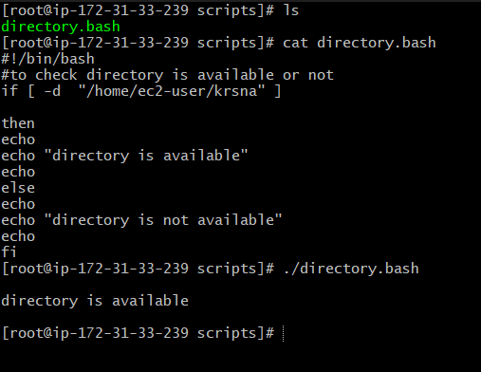

1. Create a bash script which will create multiple files.

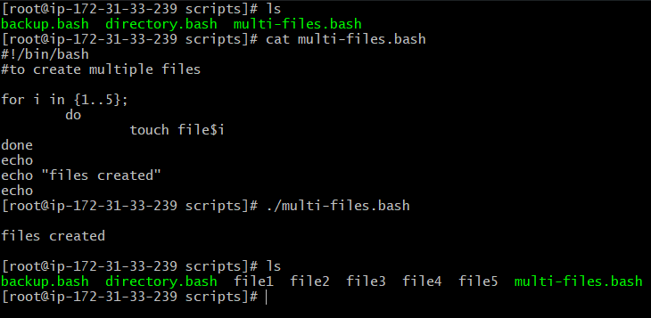

1. Create a bash script to take backup of a directory.

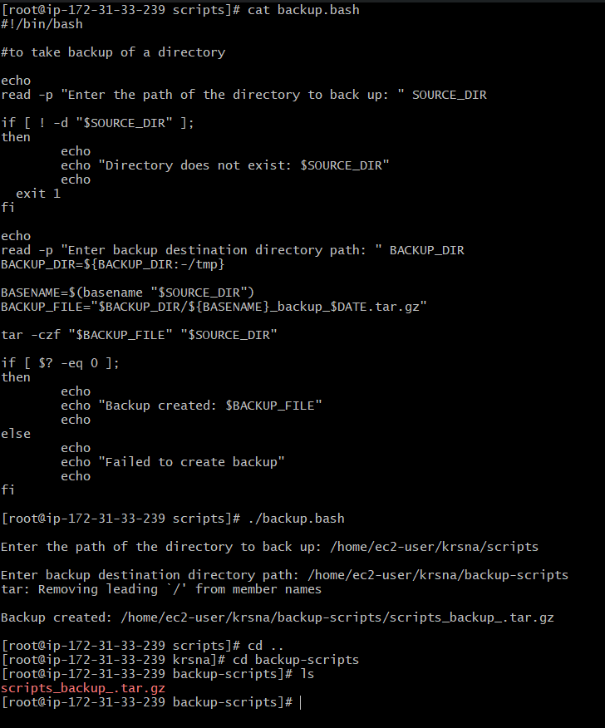

1. Create a bash script to install nginx in ec2 server.

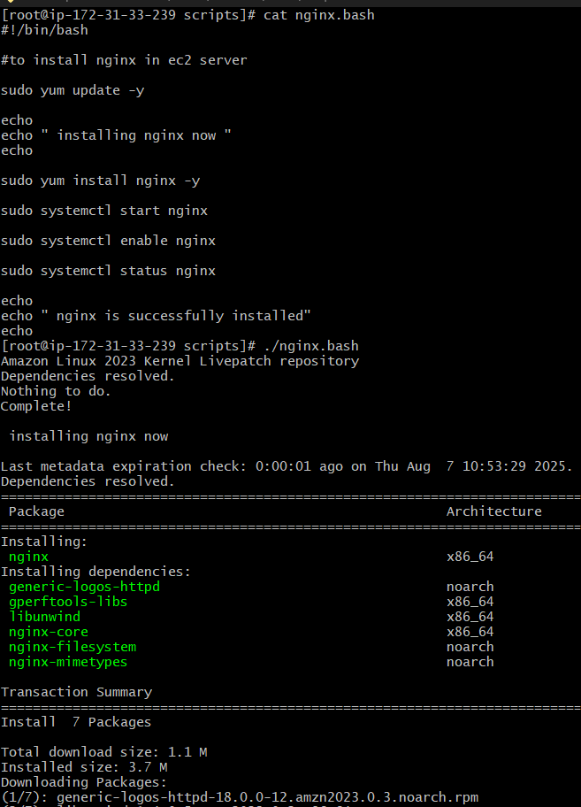

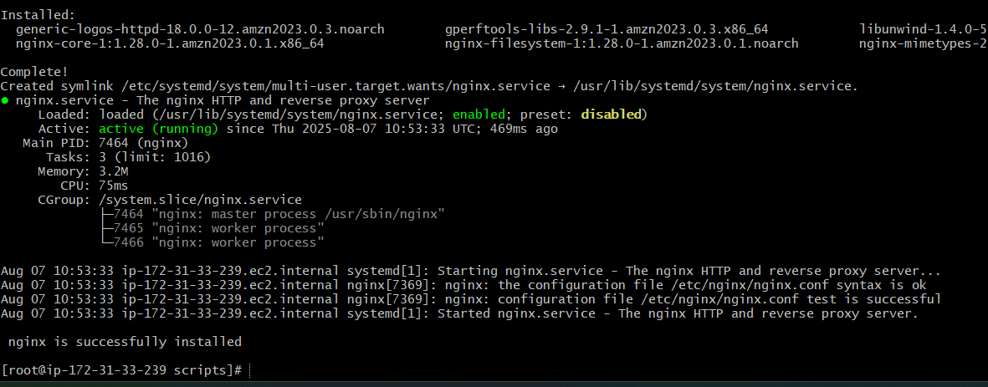

1. Create a bash script to install ApacheTomcat in ec2 server.

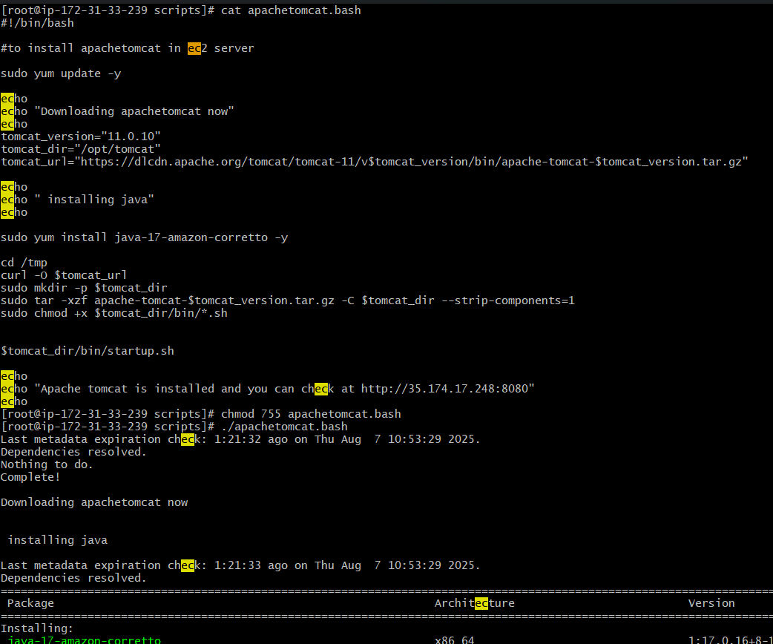

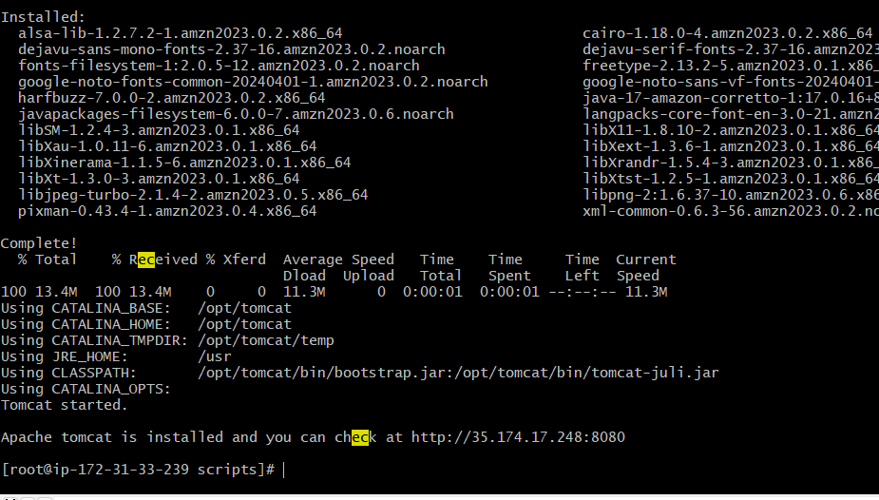

1. Create a bash script to check list if nginx service is running or not,if not running then script should start the service.

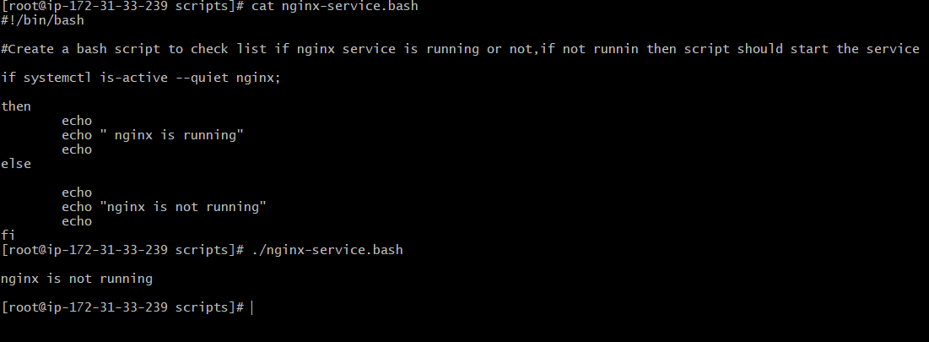

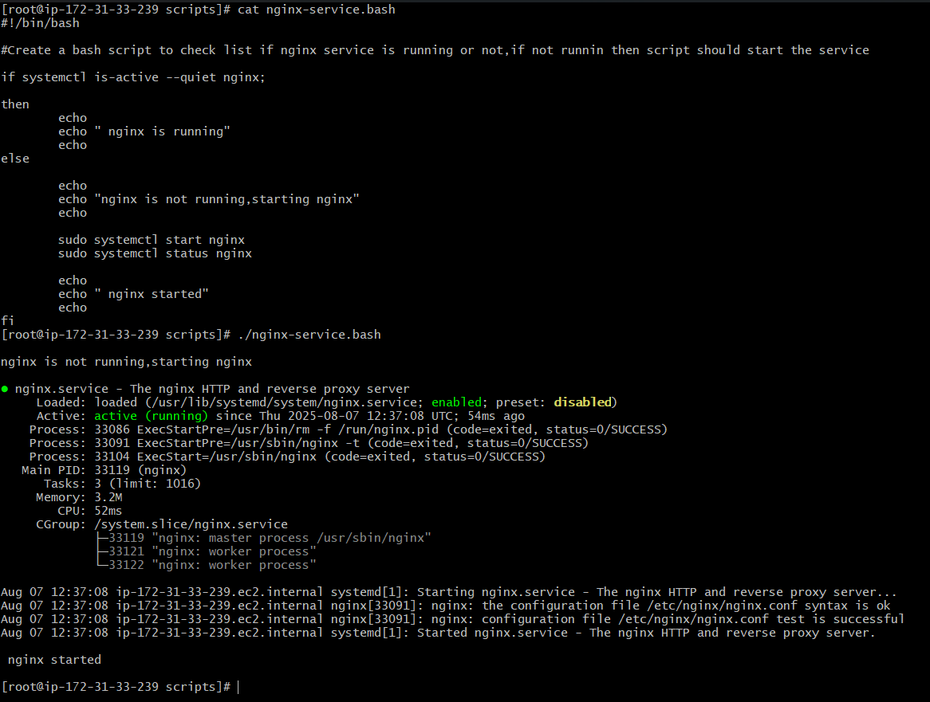

1. Create a bash script for calculator.

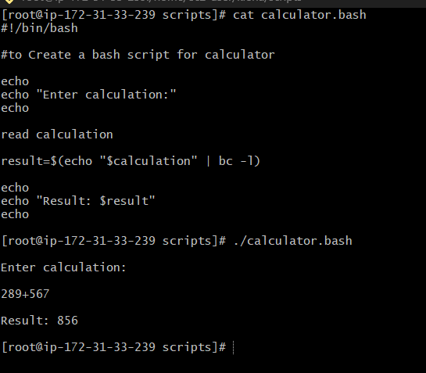

1. Create a bash script to check if directory is avaialble or not,if not then create a directory.

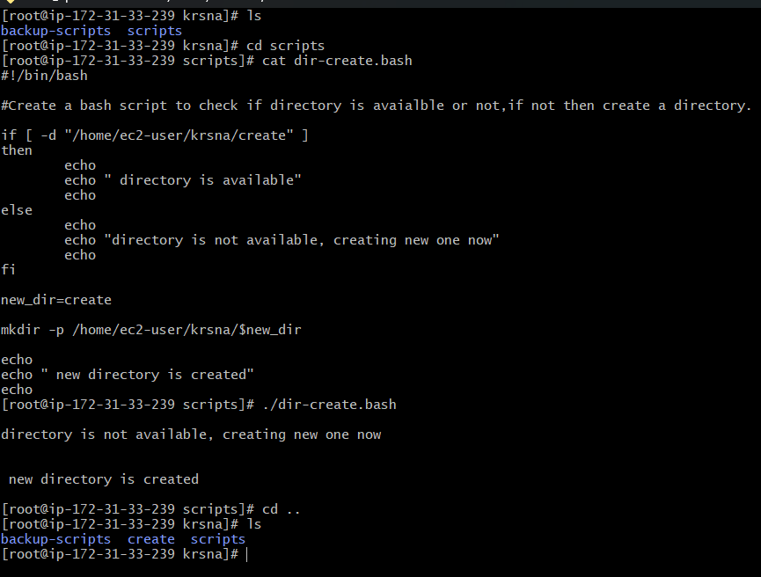

1. Create bash script to delete last 3 lines for a file.

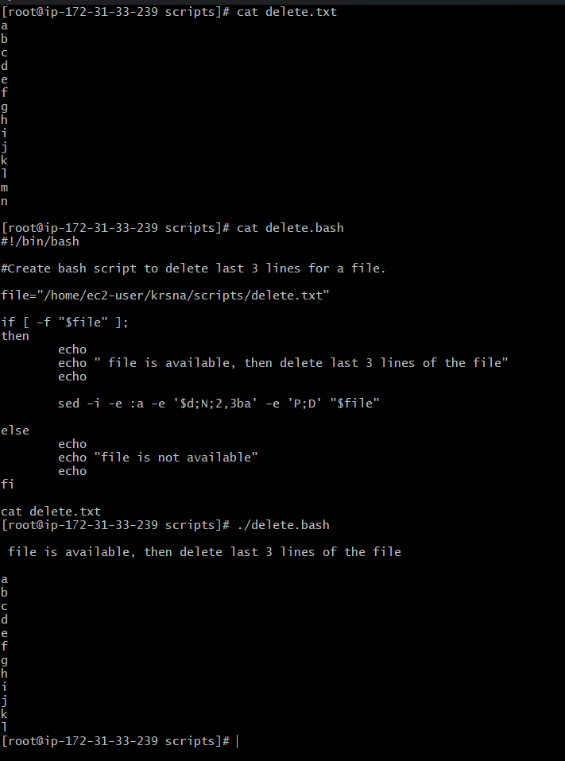

10) Bash script to monitor cpu and if it is more than 80% then send email notification.

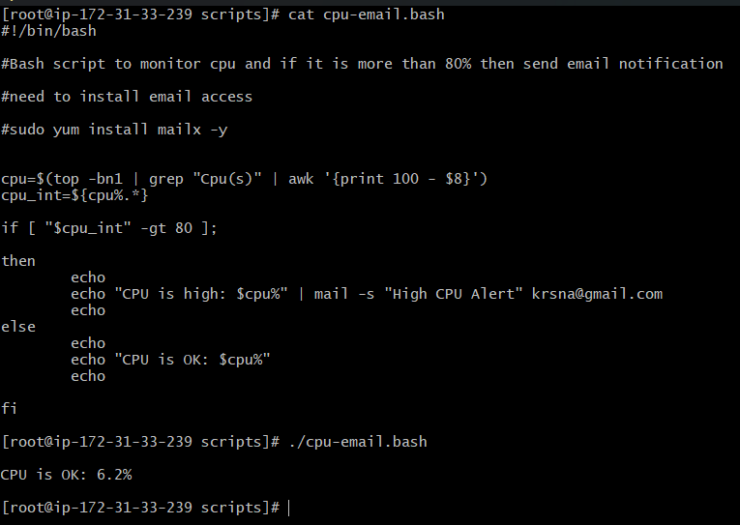

11) Bash script to monitor disk space and if it is more than 80% then send email notification.

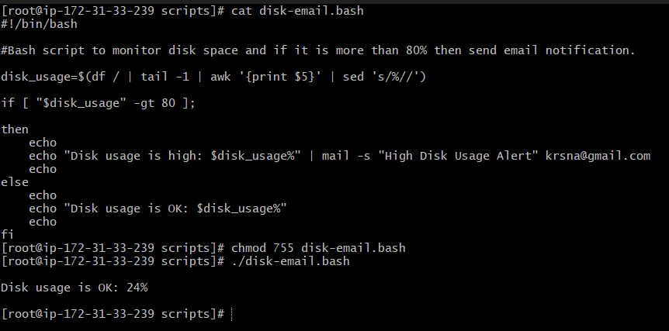

12) Bash script to monitor memory and if it is more than 80% then send email notification.

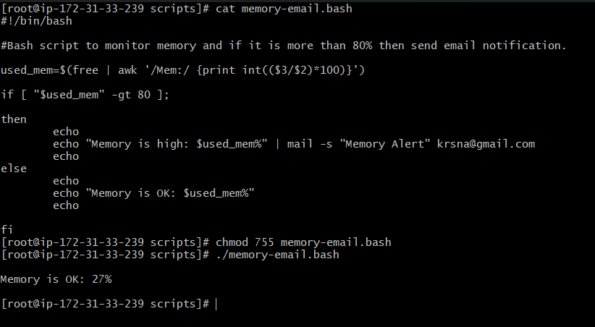

Exercise Crontab Entries :  
1) April 5th Midnight  
 2) 5 th of Every November,Jan,June if it is a Thursday.  
3) At 05 and 27th minutes of 9,10,11 hours everyday.  
4) 34 min. of 9th hour on 15th Aug.  
5) Every midnight  
6) Every Weekend ( Saturday night 11.59 )  
7) After every reboot

